Front-End Essentials  Training Assignment / Exam | Document Code | 25e-BM/HR/HDCV/FSOFT
Hanoi, 07 / 2026 | Version | 1.0
 | Effective Date | 07 / Jul / 2026

RECORD OF CHANGES
* A – Added M – Modified D – Deleted
No | Date | A/M/D | Changes | Reviewer | Approver
1 | 07/07/2026 | A | Create FE Final Group Exam — Online Learning Platform (multi-page, JS, CRUD, localStorage). | HoangPD12 | HoangPD12

Contents | Page
For the following exam:
Front-End Essentials — Online Learning Platform — Final Group Exam | 4
Working Tools & Delivery Requirements | 4
Technologies | 4
Technical Requirements | 4
Problem 01: Course Listing & Detail Pages (Static) | 5
Problem 02: Interactive Course Search & Filtering | 6
Problem 03: Lesson Player & Quiz Feature | 7
Problem 04: Admin Panel — Full CRUD + localStorage | 8
Grading Rubric | 9
Submission Instructions | 9

For the following exam:
This is a group take-home exam for groups of 6 members. Create a project folder named GroupX_fee.finalexam.t01 (replace X with your group number). Pack all files into GroupX_fee.finalexam.t01.zip and submit via XYZ@fsoft.com.vn.
- Include a README.txt listing all 6 members' names and account names.
- All pages must open and run in Google Chrome without any build step or server.
- The evaluator may ask any member to explain any part of the submission individually.
- Identical submissions between different groups → grade 0 for all involved groups.

Front-End Essentials — Online Learning Platform
Final Group Exam | Group of 6 | Take-home
Working Tools & Delivery Requirements
- Working tools: Visual Studio Code (recommended). Any text editor is acceptable.
- Delivery: Source code in a compressed archive (.zip extension required).
- Project name: GroupX_fee.finalexam.t01 — all files inside this single folder.
- Suggested file structure:
[ PROJECT STRUCTURE ]
GroupX_fee.finalexam.t01/
├── index.html ← Course Listing page (Problem 01 + 02)
├── course-detail.html ← Course Detail + Lesson Player (Problem 03)
├── admin.html ← Admin CRUD Panel (Problem 04)
├── style.css ← Shared styles
├── app.js ← Shared JS (data, utility functions)
├── admin.js ← Admin page logic
├── detail.js ← Detail/quiz page logic
├── images/ ← Any image assets
└── README.txt ← Group members list

Technologies
- HTML5, CSS3, Bootstrap 5 (CDN — no npm). Bootstrap Icons allowed.
- Vanilla JavaScript (ES6+). No jQuery, no React, no Vue.
- localStorage — required for Problems 03 and 04 to persist data across page refreshes.
- Chart.js (CDN) — optional, only if used for the admin dashboard widget in Problem 04.
- All assets (images, fonts) must be included in the project folder — no remote CDN for images.

Technical Requirements
- All pages must be fully responsive: correct layout on desktop (≥992 px), tablet (768–991 px), and mobile (< 576 px).
- Follow standard naming convention: lowercase filenames, class names in kebab-case (e.g. course-card), JS variables in camelCase.
- No inline style="..." attributes. Use CSS classes only. No inline onclick="..." — use addEventListener.
- Code must be readable and well-commented. Each JavaScript function must have a one-line comment describing its purpose.

Problem 01 — Course Listing & Detail Pages (Static) [25%]
Overview: Build the visual shell of the platform: a Course Listing page (index.html) and a Course Detail page (course-detail.html). In this problem, data is hardcoded in a JS array — no user interaction yet.
1a — Shared Navbar & Footer
[ SHARED NAVBAR ]
┌─────────────────────────────────────────────────────────────────┐
│ [Logo] LearnHub Courses About Contact [🔍 Search] Login│
└─────────────────────────────────────────────────────────────────┘
Collapses to hamburger (☰) on mobile. "Login" is a button styled with Bootstrap.
The Footer spans full width: 3 columns (About LearnHub | Quick Links | Contact), copyright line at bottom. Consistent on both pages.
1b — Course Listing Page (index.html)
[ COURSE LISTING PAGE ]
Hero Section:
┌─────────────────────────────────────────────────────────────┐
│ Grow Your Skills with LearnHub │
│ "Explore 100+ expert-led courses at your own pace." │
│ [Browse Courses ▶] [Learn More] │
└─────────────────────────────────────────────────────────────┘

Category Tabs (below hero):
[ All ] [ Web Dev ] [ Design ] [ Data Science ] [ Marketing ]

Course Cards Grid (Bootstrap: 3 cols on lg, 2 on md, 1 on sm):
┌──────────────┐ ┌──────────────┐ ┌──────────────┐
│ [Thumbnail] │ │ [Thumbnail] │ │ [Thumbnail] │
│ Course Title │ │ Course Title │ │ Course Title │
│ ⭐ 4.8 (120) │ │ ⭐ 4.5 (89) │ │ ⭐ 4.9 (240) │
│ 👤 Instructor│ │ 👤 Instructor│ │ 👤 Instructor│
│ 📚 12 lessons│ │ 📚 8 lessons │ │ 📚 20 lessons│
│ $49 [Enroll]│ │ FREE [Enroll]│ │ $89 [Enroll]│
└──────────────┘ └──────────────┘ └──────────────┘

Show at least 6 hardcoded courses across 3 categories.
Example — Course Listing page layout:
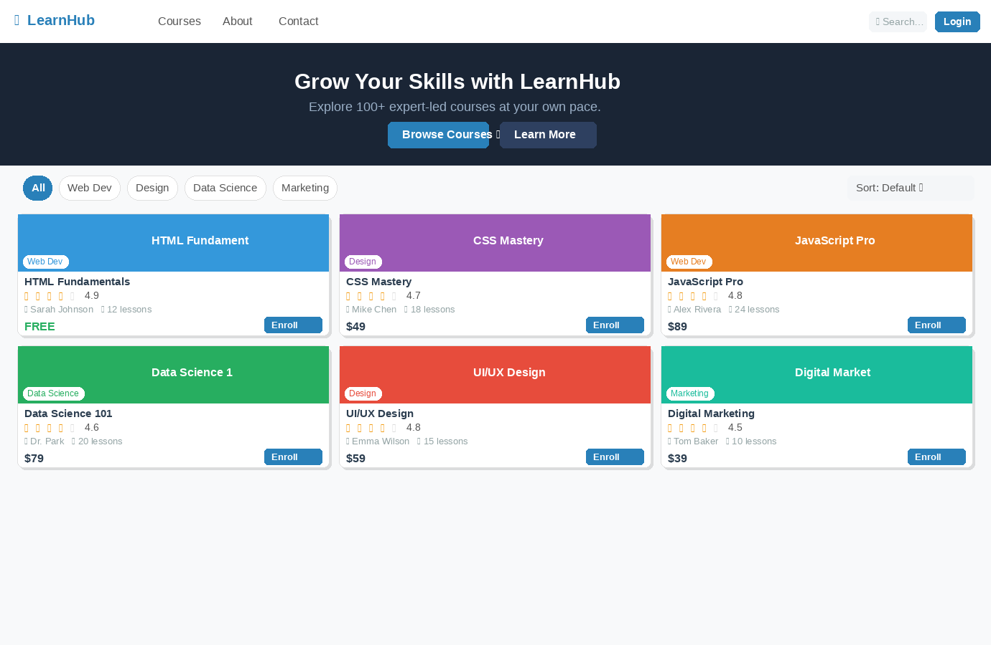
1c — Course Detail Page (course-detail.html)
[ COURSE DETAIL PAGE ]
Left (col-lg-8): Right (col-lg-4) — sticky sidebar:
┌───────────────────────────────┐ ┌──────────────────────┐
│ [Video/Image Banner] │ │ [Course Thumbnail] │
│ Course Title (h1) │ │ $49 │
│ ⭐ 4.8 • 1,200 students │ │ [Enroll Now ▶] │
│ By: Instructor Name │ │ This course includes: │
├───────────────────────────────┤ │ ✅ 12 video lessons │
│ What You'll Learn (4 bullets) │ │ ✅ Lifetime access │
├───────────────────────────────┤ │ ✅ Certificate │
│ Course Description (2 paras) │ │ ✅ Mobile-friendly │
├───────────────────────────────┤ └──────────────────────┘
│ Curriculum (Accordion): │
│ ▶ Section 1 — 3 lessons │
│ ▶ Section 2 — 4 lessons │
│ ▶ Section 3 — 5 lessons │
└───────────────────────────────┘

Use Bootstrap Accordion for the curriculum. Data is hardcoded.
Example — Course Detail page layout:
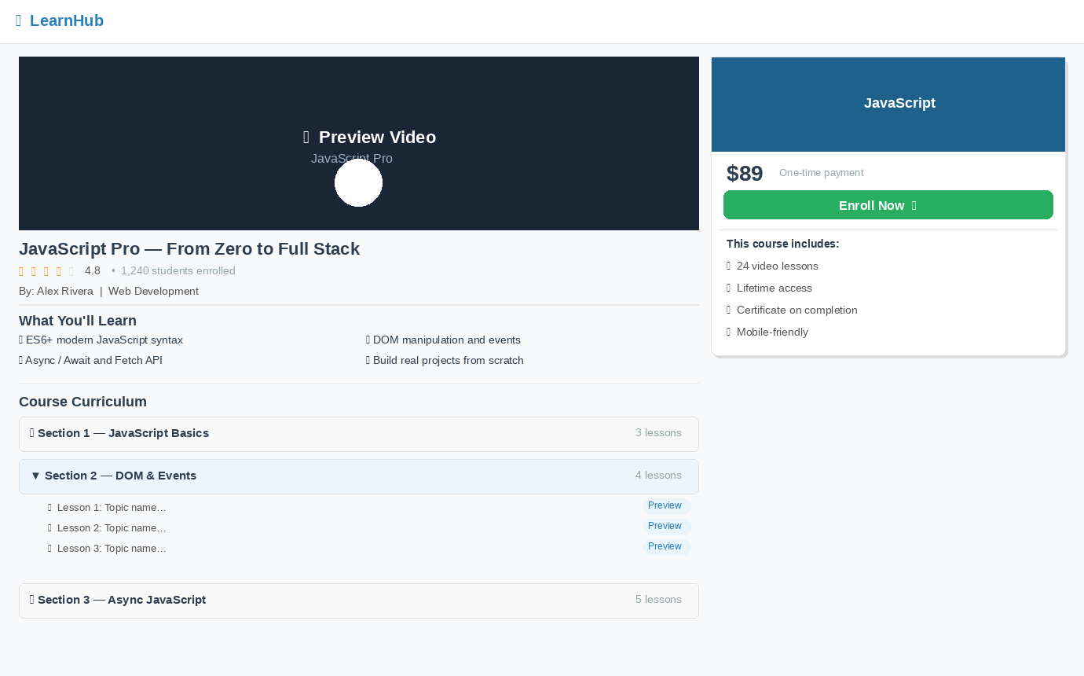

Problem 02 — Interactive Course Search & Filtering [20%]
Overview: Make the course listing page interactive. All filtering is done in JavaScript on the hardcoded courses array — no page reload.
- [8%] Search + Live Filter — Add a live search input in the navbar or above the course grid:
- As the user types, filter the course cards in real time. Match against Course Title and Instructor Name (case-insensitive).
- Cards that do not match are hidden (not removed from the DOM). Show a "No courses found" message if the filtered result is empty.
- Clicking the clear (✕) icon or deleting all text resets the list immediately.
- [7%] Category Filter Tabs — The category tabs above the course grid are interactive:
- "All" shows every course. Clicking a specific category shows only courses in that category.
- Search and category filter work together: if the user has searched for "JavaScript" and clicks "Web Dev", only Web Dev courses matching "JavaScript" are shown.
- The active tab is visually highlighted (Bootstrap nav-link active class or custom style).
- [5%] Sort Dropdown — A dropdown above the grid (e.g. "Sort by"):
- "Default" — original order.
- "Price: Low to High" / "Price: High to Low" — re-render cards sorted by price.
- "Rating: High to Low" — re-render sorted by star rating descending.

Problem 03 — Lesson Player & Quiz Feature [25%]
Overview: Add interactivity to course-detail.html: a lesson video player simulation and a quiz at the end of a section. Progress is saved to localStorage.
- [10%] Lesson Progress Tracker
- Each lesson in the curriculum accordion has a checkbox (✅). When the user ticks a checkbox, mark that lesson as complete (store in localStorage as an array of completed lesson IDs).
- Show a progress bar at the top of the curriculum section: "X / Y lessons completed" fills proportionally.
- When the page reloads, the checkboxes and progress bar must restore from localStorage.
- If all lessons in a section are complete, the section header shows a ✅ badge.
- [15%] Section Quiz
After the last lesson of each accordion section, show a "Take Quiz" button. Clicking it reveals an inline quiz panel:
[ QUIZ PANEL (inline, below section accordion) ]
┌─────────────────────────────────────────────────────┐
│ Quiz: Section 1 │
│ │
│ Q1. What does HTML stand for? │
│ ◯ a) HyperText Markup Language │
│ ◯ b) HighText Machine Language │
│ ◯ c) Hyperlink Text Markup Language │
│ ◯ d) None of the above │
│ │
│ Q2. Which tag defines a paragraph? │
│ ◯ a) <para> ◯ b) <p> ◯ c) <pg> │
│ │
│ Q3. (add at least 3 questions per section) │
│ │
│ [Submit Quiz] │
└─────────────────────────────────────────────────────┘
Example — Quiz panel showing questions, radio options, and pass result banner:
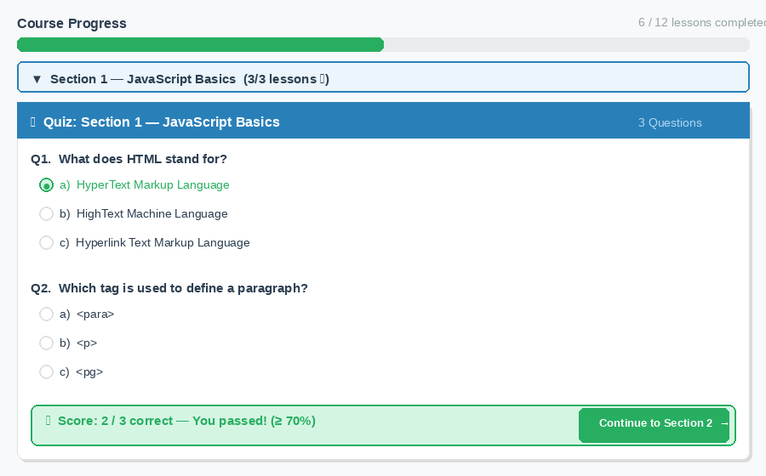
- Each section must have at least 3 multiple-choice questions with 3–4 options. Answers are hardcoded in the JS.
- On "Submit Quiz": calculate the score (e.g. "2 / 3 correct"). Show each question result inline: correct answer in green, wrong in red.
- If the score ≥ 70%, show a pass message and a "Continue to next section" button that opens the next accordion panel. Save the pass/fail to localStorage.
- If score < 70%, show a fail message and a "Retake Quiz" button that resets the form.

Problem 04 — Admin Panel — Full CRUD + localStorage [30%]
Overview: Build a separate admin.html page where an admin can manage the course catalogue. Data is stored in localStorage and must persist across page refreshes.
Admin Page Layout
[ ADMIN PANEL (admin.html) ]
Top: Navbar with [Logo] | "Admin Panel" | [👤 Admin] [Logout]

Left sidebar (fixed, same pattern as Problem 01 dashboard):
🏠 Dashboard | 📚 Courses | 👤 Instructors | 📊 Reports

Main area — default active view: Courses Management
┌──────────────────────────────────────────────────────────┐
│ Courses Management [+ Add New Course] │
│ [🔍 Search courses...] [Category ▼] [Status ▼] │
│ │
│ ┌────┬──────────────────┬──────────┬───────┬──────────┐│
│ │ # │ Title │ Category │ Price │ Actions ││
│ ├────┼──────────────────┼──────────┼───────┼──────────┤│
│ │ 1 │ HTML Fundamentals│ Web Dev │ FREE │ ✏️ 🗑️ ││
│ │ 2 │ CSS Mastery │ Design │ $49 │ ✏️ 🗑️ ││
│ └────┴──────────────────┴──────────┴───────┴──────────┘│
│ Pagination: [◀ Prev] 1 2 3 [Next ▶] (5 per page) │
└──────────────────────────────────────────────────────────┘
Example — Admin Panel layout (sidebar + CRUD table + search/filter + pagination):
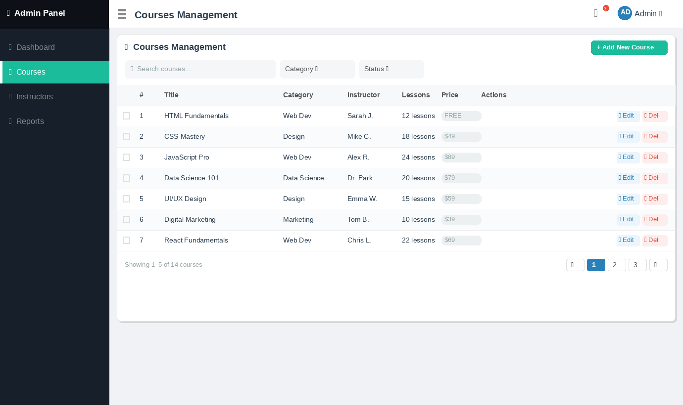

Required Features
- [8%] localStorage Persistence — On page load, admin.js reads the course list from localStorage. If nothing is stored, seed it with the same 6 hardcoded courses from Problem 01. Every Create/Update/Delete operation must immediately update localStorage.
- [5%] READ + Search + Filter — Render the courses in the table. Search bar filters by title (live, as the user types). Category and Status dropdowns filter the table. Show a "No results" row if empty. Apply all filters simultaneously.
- [5%] Pagination — Display 5 courses per page. Show page numbers at the bottom. "Prev" / "Next" buttons. When search/filter changes the result set, reset to page 1.
- [6%] CREATE — "+ Add New Course" button opens a Bootstrap modal with:
- Title (text, required, min 5 characters)
- Category (select: Web Dev / Design / Data Science / Marketing / Other)
- Instructor Name (text, required)
- Lesson Count (number, required, 1–100)
- Price (number, ≥ 0 — enter 0 for Free)
- Rating (number, 1.0–5.0)
- Status (select: Published / Draft)
On submit: validate, generate an ID, push to the array, save to localStorage, re-render table, close modal, show toast "Course created."
- [5%] UPDATE — ✏️ (Edit) button opens the same modal pre-filled with the course's current data. On save: update the object in the array, save to localStorage, re-render, show toast "Course updated."
- [6%] DELETE — 🗑️ (Delete) button shows a confirmation modal. On confirm: remove from array, save to localStorage, re-render. If deleted course was being edited, close the edit modal first. Show toast "Course deleted."

Bonus (+5% extra each): (a) Bulk delete: checkboxes on each row + "Delete Selected" button. (b) Export to CSV: a button that downloads the current filtered course list as a .csv file using JavaScript Blob.

Grading Rubric

Prob | Section | Assessment Criteria | Weight
01 | Course Listing & Detail (Static) | Layout fidelity, accordion, responsive grid, shared navbar/footer | 25%
02 | Search, Filter & Sort | Live search, category tabs, sort — all work together | 20%
03 | Lesson Player & Quiz | Progress bar, localStorage, quiz scoring, pass/fail logic | 25%
04 | Admin CRUD + localStorage | Full create/read/update/delete, pagination, persistence | 30%
 | TOTAL |  | 100%

Submission Instructions
- Zip name: GroupX_fee.finalexam.t01.zip
- Contains the full project folder. All pages open in Chrome without a server.
- Include README.txt with all 6 member names + account names.
- Submit via XYZ@fsoft.com.vn or class admin's designated channel by the announced deadline.

— THE END —

